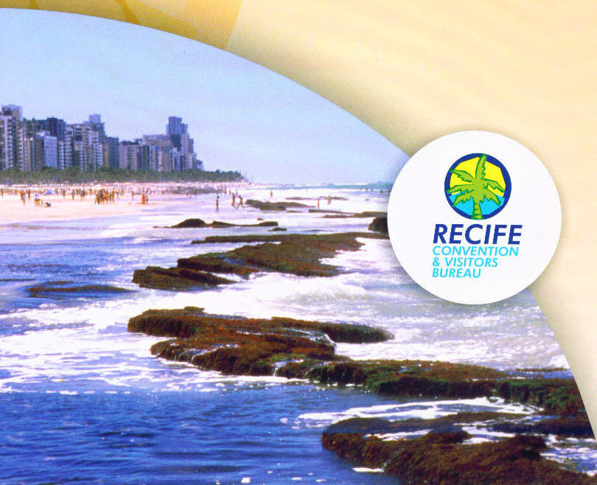
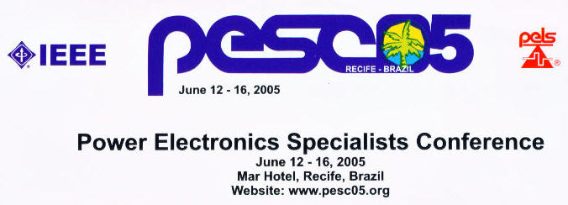

Topics of Interest
- Power Semiconductor Devices  - Inverters (VSI and CSI)  - AC-AC and Matrix Converters  - Rectifiers  - DC-DC Converters  - Resonant Converters  - Converter Control Techniques  - System Power Factor Correction  - Modeling, Analysis and Simulation  - Integration, Packaging and Modules | - Motor Drives  - Power Quality and Utility Interface Issues  - Intelligent Systems  - Passive Components  - Energy Storage  - Distributed Generation and Renewable Energy  - Power Supplies and Consumer Applications  - Automotive Applications  - Aerospace Power Applications  - Other Power Electronic Applications
Special Session : Diagnostics and Fault-Tolerant Applications, organized by Dr. A.J. Marques Cardoso
Special Session : Very Large Power Drives and Converters, organized by Dr. Fei Wang
Tutorials : send your tutorial proposal to Dr. Jorge L. Duarte (j.l.duarte@tue.nl)
Power Electronics Education Workshop (PEEW) - Authors are invited to submit papers in power electronics education for both oral and poster sessions. A power electronics education workshop will be held in conjunction with PESC ’05 (June 16-17, 2005). The workshop will discuss various delivery technologies available and how to implement them to power power electronics courses at both undergraduate and graduate levels. Keynote speakers and a luncheon will convene the participants. Discussions on industry needs, adaptation to modern university curricula, modern laboratories, use of simulation and web technology in education will be also a focus of this workshop. The workshop proceedings will be indexed by IEEE and published in a separate CD-ROM. For further information contact : Prof. Marcelo Godoy Simoes (mgsimoes@ieee.org)

Deadlines  Submission of Abstracts and Digests: October 29th 2004  Author’s Notification of Acceptance: February 15th, 2005  Submission of Final Manuscripts: April 15th 2005 | Paper Submission :  Authors should submit electronically, through www.webstracts.com a 300 words abstract plus a digest of 5 pages outlining the work. Further submission details are available at www.pesc05.org

PESC’ 05 General Chair and  Local Secretariat  Edison R. da Silva  PESC’05/DEE/CCT/UFCG  CP 10.005  Campina Grande, PB, Brazil  E-mail : edison@dee.ufcg.edu.br | PESC’05 Conference Secretariat  Bob Myers  799 North Beverly Glen  Los Angeles, CA 90077, USA  Phone (310) 446-8280  FAX (310) 446-8390  E-mail : bob@myers-smith.com | PESC’05 Program Chair and  PEEW’ 05 Chair  Marcelo G. Simoes  Colorado School of Mines  1610 Illinois St.  Golden, CO, 80401-1887, USA  E-mail: msimoes@mines.edu

