The Abstract’s Title Should Be Descriptive and Unique
Student participation support IS requested.

I.M. Author and M. Too

Company, University or Laboratory Name

1000 Street Address
City, State, Country
The extended abstracts that we accept for the Semiconductor Interface Specialists Conference should follow this general format. Because the SISC is intended for the presentation of new material, work that has appeared in print prior to the submission deadline will not be considered for presentation. For lack of a better topic, this abstract discourses on the format and the conference itself. The abstract should make a clear distinction between background material and new work, and should include enough information to show how the work advances the state of the art. While giving examples is not a particularly unique idea, our implementation is slightly different than what has been done elsewhere. This abstract, with the proper format intended for publication in the Abstract Book, was produced using Word® 2000 and rendered into PDF format using Adobe Acrobat® 5.0. References are placed at the end of the abstract using the “endnote” feature in Word. In this version, the identities of the authors are disclosed in the title area and references for the printed abstract book.
The abstracts should be original work, and summarized in two pages or less, including figures and references. The text type font must be in Times New Roman and Symbol fonts that are 11-point or larger. The text on each 8.5” × 11” page must remain within 1” margins. No more than 6 figures may be used, with 2-4 figures being ideal. The figures must be large enough to be read easily and caption fonts may be no smaller than 10 point. Examples are given on the following page.
This example is formatted for 8.5” × 11” paper, which is standard in the US. Since all abstracts are to be submitted electronically, please setup the page so that it is Letter (8.5 × 11 in.) size, and all margins are 1.0”. All accepted abstracts will be printed onto this type of paper for printing and binding of the final Book of Abstracts, so the format is very important.
As was done last year, abstracts will be submitted electronically. To minimize the size of your electronic file, take care to paste figures in a suitable format using your word processor, such as a Windows Meta File (WMF), JPEG or TIFF. Converted PDF files should generally be ≤200 KB. Send your abstract in PDF format with the procedure listed below.
Electronically submit your abstract by attaching the PDF files in an email with the following:
- To: rwallace@unt.edu and bellman@imit.kth.se
- Subject: 2002 SISC submission
- The first line/paragraph of the email is the exact title
- The second line/paragraph lists the author(s)
- The contact author name, address, phone, fax numbers, and e-mail address should follow.
- One file of the abstract, including the name and affiliation of the authors. Filename = “Abstract.pdf”
- One file of the abstract without the name or affiliation of the authors, “Review.pdf”. The program committee will conduct a blind review of the submissions, so references that might identify authorship should be hidden.

Abstracts must be received by August 5, 2002. Late news is generally not accepted at this conference. However a late abstract may be considered if the results are dramatic, significant and the implications are far-reaching. The procedure for submitting late news is identical to that for submitting regular abstracts.
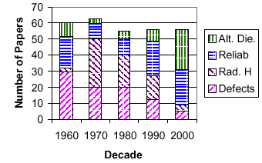
Typically about 60 papers are accepted at the SISC. The topics of such papers have varied over the years, as shown in the fabricated example for a figure, viz. Figure 1. The figure caption fonts are smaller, and the figures (black and white or gray scale only) must still be legible. As shown in this example, a figure may be inset in a paragraph, so the space on each page may be efficiently utilized. However, this is not required. Figures may be grouped at the end, as shown with the fabricated Figures 2 and 3, or inserted between paragraphs (not illustrated). Of course, the inset paragraph idea works best if there is enough text to fill up the space opposite the table.
Figure 1. Fabricated data illustrating the shift in popular topics at the SISC. Any similarity between this and actual history is coincidental. Color in figures are NOT reproducible in the SISC Abstract book.

For your amusement, we have fabricated other sets of data to demonstrate an abstract with three figures. You may use up to six figures, but this significantly limits the available text space. The data in Figures 2 and 3 reflect a personal opinion on what makes SISC such a great conference. The technical content of the papers are highly educational, and give insight and a new perspective. But, the people of the conference are truly outstanding and the social functions allow interaction with the greatest and best in this field.
In conclusion, please use this example abstract to set the formatting of your abstract as you would like it to appear in the Abstract Book. This document was created in MS Word, Letter (8.5 × 11 in.) with 1 in. margins using New Times Roman and Symbol 11 pt. Fonts, then converted to a PDF file via the Adobe software.
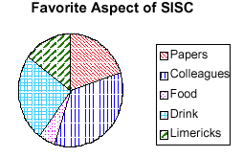
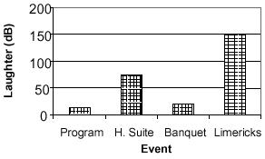
Figure 2. An opinion on the favorite aspects of the SISC. Color figures can NOT be reproduced.
Figure 3. A measure of the amusement observed at various SISC events.

IEDM, MRS, and ECS to name a few.
For example, this reference.
SISC Technical Chair – this reference discloses the author and should be eliminated in the “review” version of the abstract. This can be simply done by changing the text color from black to white.

