
EUROSIM’04

5th EUROSIM Congress
on
Modelling and Simulation

6–10 September 2004

ESIEE, Cité Descartes, Marne la Vallée, France

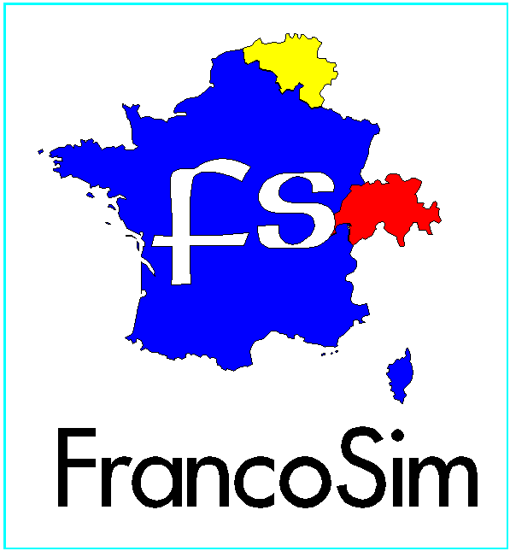

Conference Themes

Adaptive simulation
Bondgraph simulation
Biomedical systems
Control systems
Complex systems
Continuous simulation
Component based modelling
Data mining
Distributed systems
Decision support systems
Discrete event simulation
Expert systems
Fuzzy simulation
Genetic algorithms
Graphical modelling
Hybrid modelling
Hierarchical modelling
Heterogeneous systems
High complexity systems
High performance computing
Integrated modelling
Intensive computation
Knowledge based systems
Large scale systems
Model validation
Man-in-loop simulation
Mathematical modelling
Mathematical methods in simulation
Methodology of complex societal problems
Methodology of systems modelling
Multi-agent based systems
Model based shape recognition
Neural networks
Network simulation
New inductive and deductive methods
Open systems
Operations research
Optimisation by simulation
Parallel modelling
Parallel processing
Petri nets
Real-time systems
Stochastic systems
Statistical modelling
Scientific computation
Self-organising systems
WEB based simulation
The EUROSIM 2004 Congress will be organised by the French Speaking Simulation Society (FRANCOSIM) on behalf of the Federation of European Simulation Societies (EUROSIM). It will take place in September 2004 at ESIEE in Marne la Vallée, France. It aims to address the impact of simulation science on the society in general. Contributions are solicited on all aspects of natural and life sciences including experimental and computational physics, mathematical engineering, applied chemistry, structural architecture, environmental management, economics and econometrics, operations research, social and behavioural sciences such as experimental philosophy and applied psychology.

Submission:

Extended abstracts as well as full papers must be written in English and they should not exceed 2 and 6 pages respectively, following the guidelines of the author’s kit available on the web-page. The first page must include the title of the paper, author(s) names and affiliation, postal address, fax number, email address for correspondence, a list of keywords and an abstract. Authors are strongly encouraged to submit their papers electronically, following the guidelines available via the web-page. Authors who cannot submit electronically must contact the conference chair at y.hamam@esiee.fr .

Proposal of Special sessions:

Interested persons may propose special sessions and invite contributors in the corresponding field.

Publications:

Proceedings of the accepted papers will be distributed at the conference. Selected papers on special issues may be published in the SIMPRA Journal.

Important dates:

January 9th, 2004: proposal of special sessions
March 1st, 2004: submission of extended abstracts
April 9th, 2004: acceptance of extended abstracts
May 10th, 2004: submission of full papers
May 28th, 2004: final acceptance of papers
June 6th, 2004: authors’ and early registration

Web Page: http://www.esiee.fr/~eurosim4

Conference chair and contact:

Yskandar Hamam

y.hamam@esiee.fr
Applications

Aerospace
Agriculture
Architecture
Applied chemistry
Applied psychology
Biology
Business
Behavioural science
Biomedical Engineering
Constructions
Communications
Energy
Environment
Ecological systems
Economics/econometrics
Experimental & computational physics
Geotechnics
Infrastructures
Industrial design
Industrial processes
Image synthesis
Logistics
Military
Medicine
Medical imaging
Meteorology / climate
Manufacturing systems
Materials and structures
Maintenance / reliability
Macro-economic systems
Mathematical physiology
Organisational processes
Power systems
Robotics
Social sciences
Societal problems
Seismic engineering
Simulation with a natural language-input
Traffic / Transportation
Virtual reality
Water management and distribution

