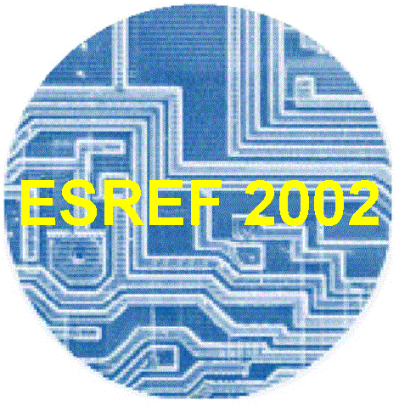
Call for Papers

ESREF2002
XIIIth European Symposium on Reliability of Electron Devices, Failure Physics and Analysis

October 7-11, 2002 – Bellaria (Rimini), Italy

This international symposium continues to focus on recent developments and future directions in Quality and Reliability Management of materials, devices and circuits for microelectronics. It provides a European forum for developing all aspects of reliability management and advanced analysis techniques for present and future semiconductor applications. The scope of the previous EOBT, Electron and Optical Beam Test Conference is included in the ESREF Conference.
Tutorials by experts will provide reviews and updates of selected topics of actual interest. Invited papers will introduce the main stream topics.
Workshops in correlation with the ESREF conference will give the opportunity to exchange the know-how and field returns on specific topics. EFUG and EUFANET meetings are scheduled on October 7th.
Equipment exhibition - The Symposium will feature the latest in service providers, equipment manufacturers and suppliers. A large exhibit floor will give the opportunity to key-vendors to represent the core business area in these fields.

SCOPE OF PAPERS

The Scientific Programme Committee is inviting you to submit a presentation proposal that addresses one or more of the following topics :

Quality and Reliability Techniques for Components and Systems
Prediction methods and tools
Reliability indicators
Yield/reliability relationship
Screening methods and burn-in
HAST , HASS
Field reliability
Failure Mechanisms in Silicon and Compound Semiconductors devices
Doping stability
Dielectrics breakdown and leakage
Hot carriers
Passivation stability
Metal migration and interaction

Non-volatile and programmable device reliability
MEMS, Sensors
Power Devices Reliability
Smart-power devices, IGBT, thyristors,
Thermal management

Photonics Reliability
Optoelectronics and laser devices,
Passive elements and modules, MOEMS
Packaging and Assembly Reliability
Bonding, solders and joints,
High densities assemblies, MCM,
BGA, CSP, flip-chip
Connectors,.

Advanced Failure Analysis : Defect Detection and Analysis
Electron, ion and laser beam techniques,
Backside techniques
Scanning probe techniques, SCM
Acoustic microscopy,
Electrical and thermal characterization,
Sample preparation, construction analysis,
Failure analysis : case studies.
Mode-Mechanism relationship.
Special Sessions are planned on:
MEMS/MOEMS
Wide Band-Gap Semiconductors
Photonic devices and systems

SUBMISSION GUIDELINES
The deadline for the submission of three page-extended summaries (including figures) is April 12th, 2002. The title page must include a five-line abstract, the complete address, fax number and e-mail address of the first author. Abstracts and papers must be written in English. For paper submission please refer to the official website : http://www.diee.unica.it/ESREF2002

Postal address:
Prof. Fausto Fantini
Università di Modena e Reggio Emilia
Dipartimento di Ingegneria dell’Informazione
Via Vignolese, 905
I-41100 Modena – Italy

