Guidelines for the Preparation of the Dialogue Session Presentations
So you are going to present a paper at the EPE 2011-Conference in Birmingham…

... congratulations! In the European professional power electronics world it is considered an honour to have a paper accepted by the international selection committee for presentation at the 14th European Conference on Power Electronics and Applications.

... and good luck, since you are, of course, eager to get your ideas across to your colleagues arriving from more than 40 countries, and you are prepared to learn from your experience. The dialogue presentation is well suited for a prolonged discussion of specialists at your poster panel.
The policy of the EPE-Association is for lecture and dialogue sessions to be of equal value!

1. Your Dialogue Presentation (Poster(s))

Although your uploaded paper will be included in the Conference Publication, the dialogue session is your great opportunity to present your work directly to other participants and to discuss it with them.

Try to attract the participants to your stand. Unless they come to it, you cannot expect to have a discussion with them. The display should therefore be visually appealing and should contain the essence of your paper in a form, which is easy to understand.

For each dialogue presentation, the local organizers will prepare two poster panels side by side (see point 4). The sets will be numbered starting with number 1 as indicated in the final programme booklet. Therefore please keep in mind your panel number. The title of the presentation must be the same title as your published paper (with authors and affiliation). The posters will be grouped by topic.

Your headlines should be visible from several meters away; so lettering should be large and clear. Your display should consist chiefly of keywords, diagrams, photographs etc … Colour photographs are particularly attractive in a display. Diagrams and graphs should have clear captions. All lettering should be easy to read. Normal typewritten or hand-written text is not allowed, but typewriting is acceptable if it is enlarged to 0.7 cm in height. All graphs and diagrams should be drawn with thick lines (preferably 1 mm or more in width). Use colour to emphasise important features. Photocopies of your typescript are not acceptable. You may also distribute information sheets. Those information sheets must be fastened directly at the board by means of your material (e. g. a fastened transparent envelope). You are responsible for the printing of your posters!

The presentation of your poster panel is important. You are recommended to take as much care with it as you did in preparing your written paper. We recommend you prepare one or two posters of the same size as recommended in point 4.

To allow the session chairs to check the preparation of the sessions, please upload the content of your presentation (poster) as a *.pdf-File by going to: https://www.cborg.info/epe2011/ => Upload Presentation.

The size limit of your file is 3 MegaByte.

The last deadline to receive the presentations is the 19th of August 2011.

2. Display, Set-Up, Attendance and Removal Times

The dialogue sessions will take place in the Exhibition area towards the rear of Hall 3. The poster sessions will take place on:
• Tuesday the 30th of August, 14.00-16.40h
• Wednesday the 31st of August, 14.00-16.40h
• Thursday the 1st of September, 14.00-16.40h
No lecture sessions will take place in parallel and the presenting author should attend his poster panel throughout this time.
The poster numbers are indicated in the programme. Authors are requested to place their poster on the relevant board before lunchtime on the day of their presentation. Posters should be removed after the dialogue session has ended.
The poster boards will be black velcro compatible boards (loop). Velcro hooks will be provided in Hall 3.
Please note: ANY POSTER THAT IS NOT REMOVED AT THE END OF THE DIALOGUE SESSION WILL BE REMOVED AND DISPOSED OF.

3. Checking your presentation

If your dialogue paper has been prepared by several authors, please make it clear which author will attend the Dialogue Session to discuss the display with the participants using a presentation advice note. Please make sure that the presenter has made himself known on the host of the conference: https://www.cborg.info/epe2011/ => I will be a speaker. An author should be present in person at the dialogue session, otherwise his paper will not be discussed and will not be uploaded into the IEEEXplore database.

4. Equipment

The following equipment will be provided for your dialogue display:

- A dialogue set with 2 panels in a V-shape. Each panel is 95 cm wide and 234 cm high, giving a usable area of 90cm x 120cm per panel. Your poster therefore should not be bigger than 90 cm wide x 120 cm high.

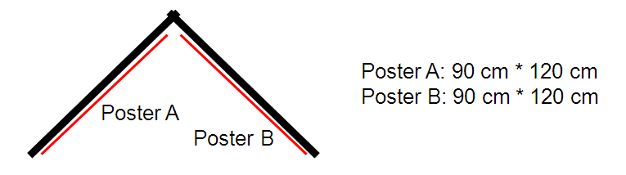
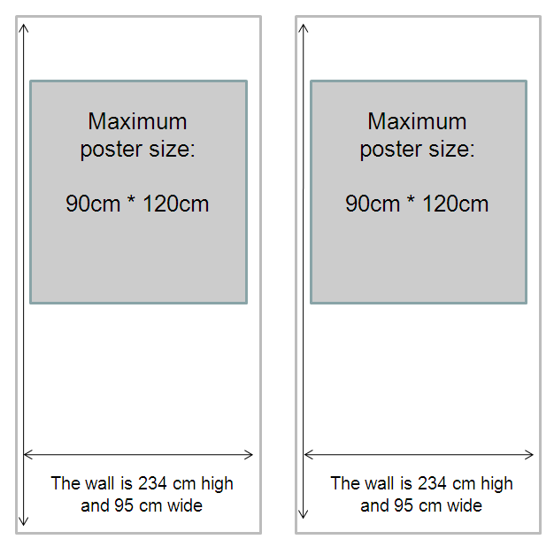

The poster(s) (part A and/or part B) can also be combined from several smaller sheets using the same area of the poster panel.

Please avoid the use of copied pages of your written paper!

- Sticking material for attaching your posters to the panels:
The sticking materials permitted are Velcro tape and will be provided by the local team.

Any additional material for the dialogue set up and display must be provided by the authors (envelopes for information sheets, pens, etc.).

Homepage of EPE2011: http://www.epe2011.com

For the uploading of your presentation, please go to

https://www.cborg.info/epe2011/ => Upload Presentation and follow the procedure.

Contact:

Local Secretariat:  University of Nottingham  Dept. of Electrical and Electronic Engineering  Rebecca Burns  University Park  Nottingham, NG7 2RN  United Kingdom  Email: info@epe2011.com  Phone: +44 (0)115 9515356 | EPE Association:  EPE Association  C/o VUB – IrW – ETEC  Pleinlaan 2, Boulevard de la Pleine  B-1050 Brussels  Belgium  E-mail: epe-association@vub.ac.be  Phone: +32-(0)2-629 28 00  Fax: +32-(0)2-629 36 20

